PUblic Perception On Artificial Intelligence

Public perception of AI, or Artificial Intelligence, has evolved over time, reflecting a mix of enthusiasm, scepticism, and concerns. Initially, AI was often portrayed in popular media as futuristic and often portrayed in a negative light, with visions of intelligent machines taking over the world. However, in recent years, AI has gained significant attention and become more integrated into everyday life, resulting in a more nuanced public perception.On one hand, there is a growing enthusiasm and optimism surrounding AI. Many people recognize the potential of AI to revolutionize various industries and improve quality of life. They see AI as a tool that can enhance productivity, automate mundane tasks, and lead to breakthroughs in fields like healthcare, transportation, and finance. AI-powered virtual assistants, smart home devices, and personalized recommendations are increasingly common, and people appreciate the convenience and efficiency they bring.

**Technical Architecture:**

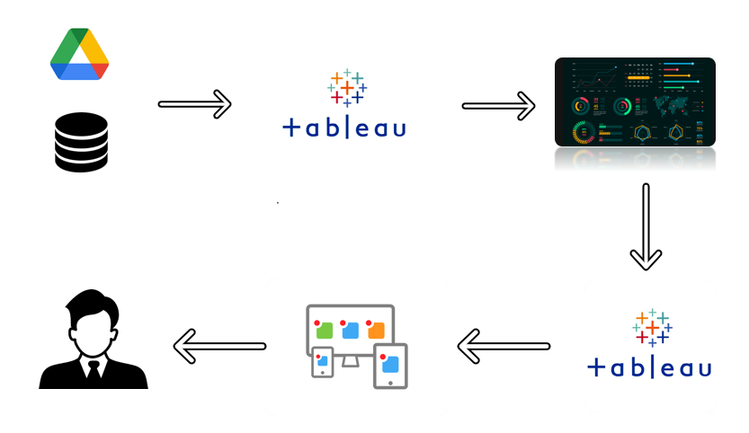

**Project Flow**

To accomplish this, we have to complete all the activities listed below,

Define Problem / Problem Understanding

* + Specify the business problem
  + Business requirements
  + Literature Survey
  + Social or Business Impact.
* Data Collection & Extraction from Database
  + Collect the dataset,
  + Connect dataset with Tableau
* Data Preparation
  + Prepare the Data for Visualization
* Data Visualizations
  + No of Unique Visualizations
* Dashboard
  + Responsive and Design of Dashboard
* Story
  + No of Scenes of Story
* Performance Testing
  + Amount of Data Rendered to DB ‘
  + Utilization of Data Filters
  + No of Calculation Fields
  + No of Visualizations/ Graphs
* Web Integration
  + Dashboard and Story embed with UI With Flask
* Project Demonstration & Documentation
  + Record explanation Video for project end to end solution
  + Project Documentation-Step by step project development procedure

**Milestone 1: Define Problem / Problem Understanding**

**Activity 1: Specify the business problem**

Refer Project Description

**Activity 2: Business requirements**

The business requirements for this project would likely include

Data collection: The first requirement is to collect data from a datasource that is relevant to Artificial Intelligence.

Data cleaning and preparation: The collected data must be cleaned and processed to ensure it is suitable for analysis. This may involve removing irrelevant information, correcting inconsistencies and missing values, and transforming the data into a format that is compatible with the analysis tools.

Data analysis: The data must be analysed to uncover meaningful insights.This could involve using techniques such as descriptive statistics, regression analysis, and data visualization to gain a deeper understanding of the data.

Report creation: The insights and findings from the data analysis must be presented in a comprehensive report that includes visualizations and data tables. The report must be well organized and easy to understand, with clear and concise explanations of the results.

**Activity 3: Literature Survey**

While I can provide a brief overview of public perception on AI, conducting a comprehensive literature survey on the topic would require access to academic databases and scholarly resources. As an AI language model, my responses are generated based on pre-existing knowledge up until September 2021, and I don't have direct access to current academic publications. Nevertheless, I can mention some key research areas and notable studies that have explored public perception of AI.

1. Trust and Acceptance: Several studies have examined the factors influencing public trust and acceptance of AI technologies. Research has explored aspects such as perceived usefulness, perceived risks, familiarity, transparency, and user experience as determinants of public attitudes towards AI.

2. Ethical Concerns: Scholars have investigated public perceptions of ethical issues associated with AI, such as privacy, fairness, bias, and accountability. These studies delve into public opinions on topics like AI's impact on employment, algorithmic decision-making, and the potential for AI to infringe upon human rights.

3. Media Influence: The role of media in shaping public perception of AI has been examined. Research has investigated how media portrayals of AI, including in movies, news articles, and social media, influence public understanding, expectations, and concerns regarding AI technologies.

4. Public Engagement and Awareness: Some studies have focused on understanding the level of public awareness and engagement with AI. These investigations explore the knowledge gaps and misconceptions among the general public and examine the effectiveness of public outreach and educational initiatives.

5. Cross-Cultural Studies: Research has also explored variations in public perception of AI across different cultural contexts. These studies examine how cultural values, norms, and beliefs shape attitudes and acceptance of AI technologies.

It's worth noting that the field of public perception on AI is rapidly evolving, and new research is continuously being published. To conduct a comprehensive literature survey, I recommend searching academic databases such as Google Scholar, IEEE Xplore, ACM Digital Library, or Scopus using relevant keywords and filters to find the latest studies on public perception of AI.

**Activity 4: Social or Business Impact.**

**Social Impact:** The findings from this project could help people have a better understanding on How Artificial intelligence will impact of Human Life .

**Business Model/Impact**: public perception on AI data helps us to estimate the How AI is replacing The Human Work Force.

**Milestone 2: Data Collection & Extraction from Database**

Data collection is the process of gathering and measuring information on variables of interest, in an established systematic fashion that enables one to answer stated research questions, test hypotheses, and evaluate outcomes and generate insights from the data.

**Activity 1: Collect the dataset**

Please use the link to download the dataset:

<https://www.kaggle.com/datasets/saurabhshahane/public-perception-of-ai>

**Activity 1.1: Understand the data**

Check the below link out to understand the dataset in detail:

<https://www.kaggle.com/datasets/saurabhshahane/public-perception-of-ai>

**Activity 2: Connect Dataset to Tableau**

Explanation video link:

<https://dexterit-my.sharepoint.com/:v:/g/personal/sam_dexterit_onmicrosoft_com/ETVkexe1qGRDnRrEtKM1xFkBn0H2uFZdZIjU0mob7XtCHQ?e=qWbAnF>

**Milestone 3: Data Preparation**

**Activity 1: Prepare the Data for Visualization**

Preparing the data for visualization involves cleaning the data to remove irrelevant or missing data, transforming the data into a format that can be easily visualized, exploring the data to identify patterns and trends, filtering the data to focus on specific subsets of data, preparing the data for visualization software, and ensuring the data is accurate and complete. This process helps to make the data easily understandable and ready for creating visualizations to gain insights into the performance and efficiency.

* **Activity 1.1** : **Preparing a Data Module**:

[**https://dexterit-my.sharepoint.com/:v:/g/personal/sam_dexterit_onmicrosoft_com/ETVkexe1qGRDnRrEtKM1xFkBn0H2uFZdZIjU0mob7XtCHQ?e=qWbAnF**](https://dexterit-my.sharepoint.com/:v:/g/personal/sam_dexterit_onmicrosoft_com/ETVkexe1qGRDnRrEtKM1xFkBn0H2uFZdZIjU0mob7XtCHQ?e=qWbAnF)

**Milestone 4: Data Visualization**

Data visualization is the process of creating graphical representations of data in order to help people understand and explore the information. The goal of data visualization is to make complex data sets more accessible, intuitive, and easier to interpret. By using visual elements such as charts, graphs, and maps, data visualizations can help people quickly identify patterns, trends, and outliers in the data.

**Activity 1: No of Unique Visualizations**

The number of unique visualizations that can be created with a given dataset. Some common types of visualizations that can be used to analyse the Rice production include bar charts, line charts, heat maps, scatter plots, pie charts,Maps etc. These visualizations can be used to compare performance, track changes over time, show distribution, and relationships between variables.

**Activity 1.1:** **Official figure and Estimated value by year**

**Explanation video link:** [**https://dexterit-my.sharepoint.com/:v:/g/personal/sam_dexterit_onmicrosoft_com/ETVkexe1qGRDnRrEtKM1xFkBn0H2uFZdZIjU0mob7XtCHQ?e=qWbAnF**](https://dexterit-my.sharepoint.com/:v:/g/personal/sam_dexterit_onmicrosoft_com/ETVkexe1qGRDnRrEtKM1xFkBn0H2uFZdZIjU0mob7XtCHQ?e=qWbAnF%20)

**Activity 1.2: value by year**

**Explanation video link:** [**https://dexterit-my.sharepoint.com/:v:/g/personal/sam_dexterit_onmicrosoft_com/EZf_-uwrjx9Lknhq2BC5FAEBfSCWl8a1N0i89X1PqmBtqQ?e=xOgEQY**](https://dexterit-my.sharepoint.com/:v:/g/personal/sam_dexterit_onmicrosoft_com/EZf_-uwrjx9Lknhq2BC5FAEBfSCWl8a1N0i89X1PqmBtqQ?e=xOgEQY)

**Activity 1.3: Top 10 value-containing area**

**Explanation video link:** [**https://dexterit-my.sharepoint.com/:v:/g/personal/sam_dexterit_onmicrosoft_com/EWGMX0FHKINFlmpDQ16_XxAB3dBelZbPHbiL-OC6zfLkPQ?e=498Rj3**](https://dexterit-my.sharepoint.com/:v:/g/personal/sam_dexterit_onmicrosoft_com/EWGMX0FHKINFlmpDQ16_XxAB3dBelZbPHbiL-OC6zfLkPQ?e=498Rj3)

**Activity 1.4: Flag Description based on year**

**Explanation video link:** **https://dexterit-my.sharepoint.com/:v:/g/personal/sam_dexterit_onmicrosoft_com/ES8XfeNx-phFoNwXflmLhSUB1eKKpQUDLXbAEC8prWrMCQ?e=yeNmfc**

**Activity 1.5: Top 5 rice production countries with map**

**Explanation video link:** [**https://dexterit-my.sharepoint.com/:v:/g/personal/sam_dexterit_onmicrosoft_com/ETeaPEX8UThIlRpB85PWhMEBElv5gqlY_VBPQfMfF7R6hg?e=zSeac4**](https://dexterit-my.sharepoint.com/:v:/g/personal/sam_dexterit_onmicrosoft_com/ETeaPEX8UThIlRpB85PWhMEBElv5gqlY_VBPQfMfF7R6hg?e=zSeac4)

**Activity 1.6: Countries with rice production**

**Explanation video link:**[**https://dexterit-my.sharepoint.com/:v:/g/personal/sam_dexterit_onmicrosoft_com/EXmxVSZ0YdxCmlhmtrxgHXIBvLa7GmM2RMqGErNsg4DnOg?e=YnGfTA**](https://dexterit-my.sharepoint.com/:v:/g/personal/sam_dexterit_onmicrosoft_com/EXmxVSZ0YdxCmlhmtrxgHXIBvLa7GmM2RMqGErNsg4DnOg?e=YnGfTA)

**Activity 1.7: Area and tonnes based on value**

**Explanation video link:** [**https://dexterit-my.sharepoint.com/:v:/g/personal/sam_dexterit_onmicrosoft_com/ERgSksLk7V5EocvzDYLKKB0BGUtPfPU6TYoz_ilwvqJ--w?e=nMgGpa**](https://dexterit-my.sharepoint.com/:v:/g/personal/sam_dexterit_onmicrosoft_com/ERgSksLk7V5EocvzDYLKKB0BGUtPfPU6TYoz_ilwvqJ--w?e=nMgGpa)

**Activity 1.8: Total no.of tonnes**

**Explanation video link:** [**https://dexterit-my.sharepoint.com/:v:/g/personal/sam_dexterit_onmicrosoft_com/EY0YV4ooP95DgqSqFRNZBmcBGz6aXeLI_y3ckbAHpKB9EA?e=Yz6YK4**](https://dexterit-my.sharepoint.com/:v:/g/personal/sam_dexterit_onmicrosoft_com/EY0YV4ooP95DgqSqFRNZBmcBGz6aXeLI_y3ckbAHpKB9EA?e=Yz6YK4)

**Milestone 5: Dashboard**

A dashboard is a graphical user interface (GUI) that displays information and data in an organized, easy-to-read format. Dashboards are often used to provide real-time monitoring and analysis of data, and are typically designed for a specific purpose or use case. Dashboards can be used in a variety of settings, such as business, finance, manufacturing, healthcare, and many other industries. They can be used to track key performance indicators (KPIs), monitor performance metrics, and display data in the form of charts, graphs, and tables.

**Activity :1- Responsive and Design of Dashboard**

The responsiveness and design of a dashboard for analysing the factors important for rice production across different countries from 1961 to 2021 analyzes various engagement metrics such as likes, high value productions,no.of tonnes from different countries. We can also help in distributing the production across different countries.

Explanation video link:

[**https://dexterit-my.sharepoint.com/:v:/g/personal/sam_dexterit_onmicrosoft_com/EeenqkmCQ-5EmBvj0uyhlOgBb7Qq8XB86KzOySEXVLk1NA?e=cMKwpx**](https://dexterit-my.sharepoint.com/:v:/g/personal/sam_dexterit_onmicrosoft_com/EeenqkmCQ-5EmBvj0uyhlOgBb7Qq8XB86KzOySEXVLk1NA?e=cMKwpx%20%20%20%20)

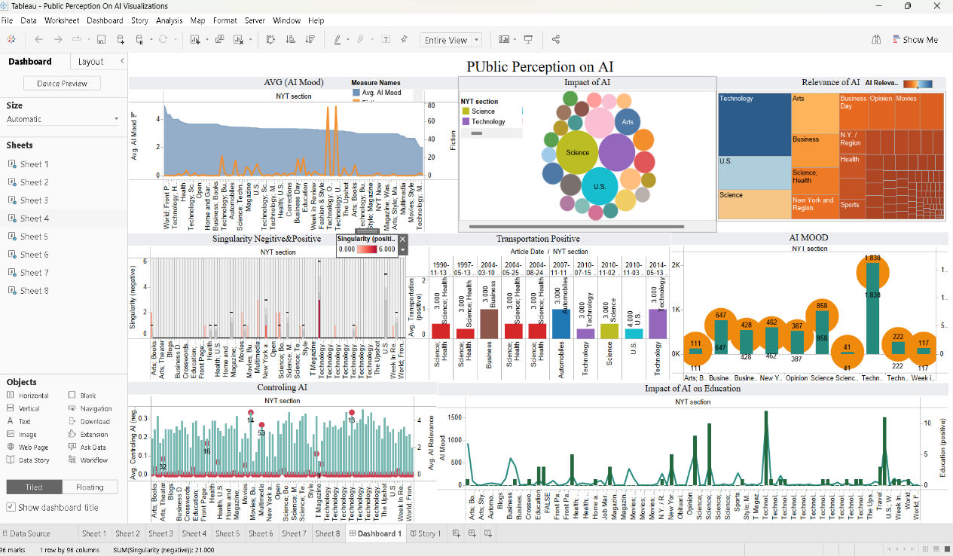

**Milestone 6: Story**

A data story is a way of presenting data and analysis in a narrative format, with the goal of making the information more engaging and easier to understand. A data story typically includes a clear introduction that sets the stage and explains the context for the data, a body that presents the data and analysis in a logical and systematic way, and a conclusion that summarizes the key findings and highlights their implications. Data stories can be told using a variety of mediums, such as reports, presentations, interactive visualizations, and videos.

**Activity:1- No of Scenes of Story**

The number of scenes in a storyboard for a data visualization analysis of the factors affecting the insights of rice production, will depend on the complexity of the analysis and the specific insights that are trying to be conveyed. A storyboard is a visual representation of the data analysis process and it breaks down the analysis into a series of steps or scenes.

**Explanation video link:**

**<https://dexterit-my.sharepoint.com/:v:/g/personal/sam_dexterit_onmicrosoft_com/Eb4xOxMRtqlDtM2MMY5TjpYBSmNfR2ZT4OUU0EPd-PDj0Q?e=OzV1cZ>**

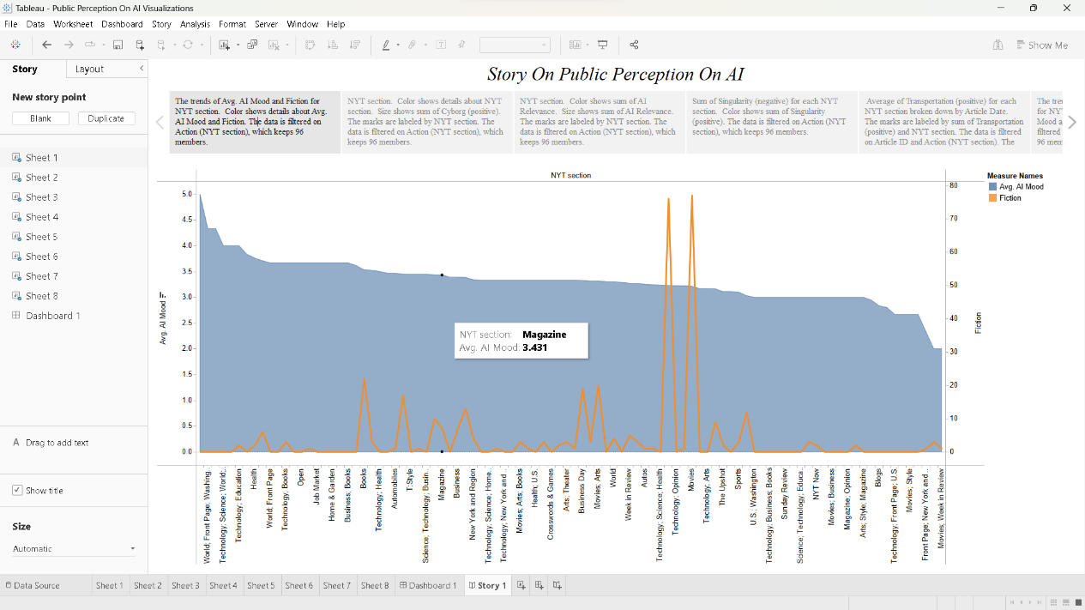

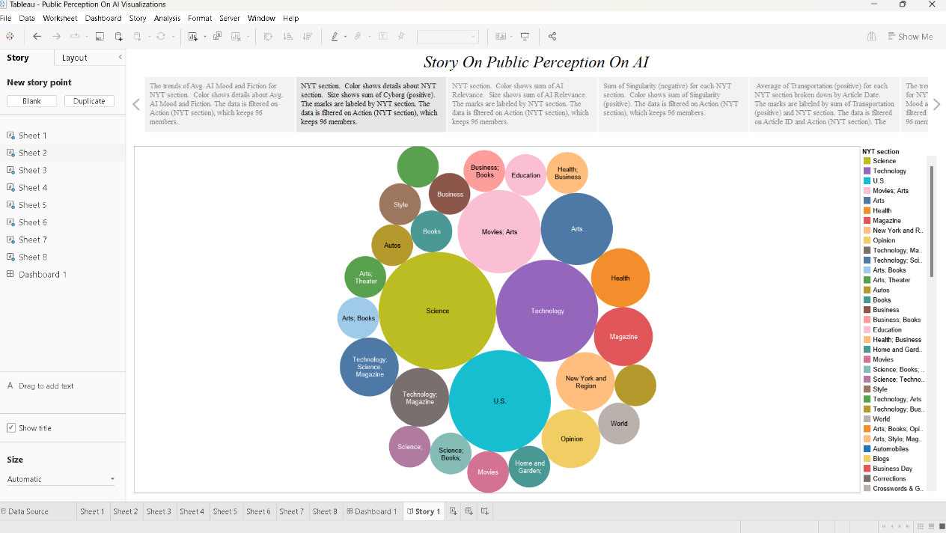

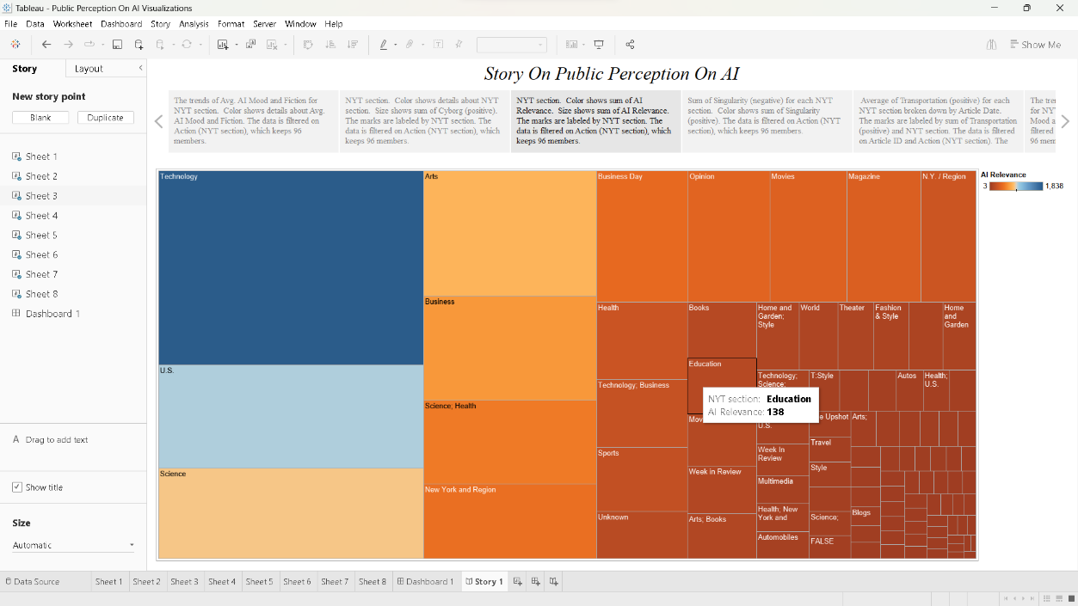

**Milestone 8: Performance Testing**

**Activity 1: Utilization of Data Filters**

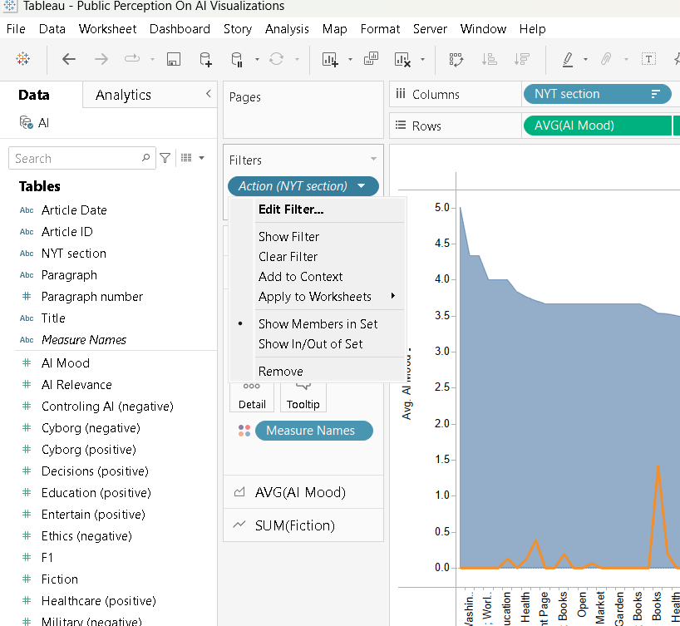

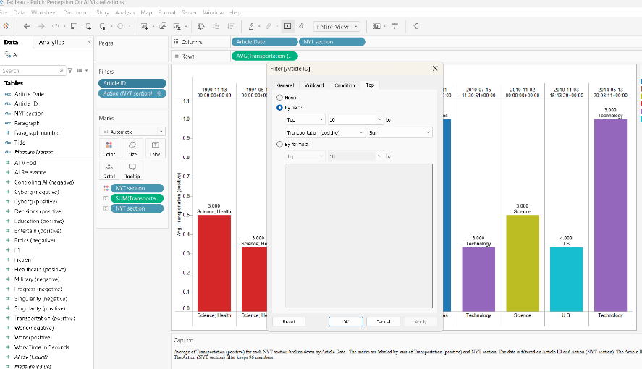

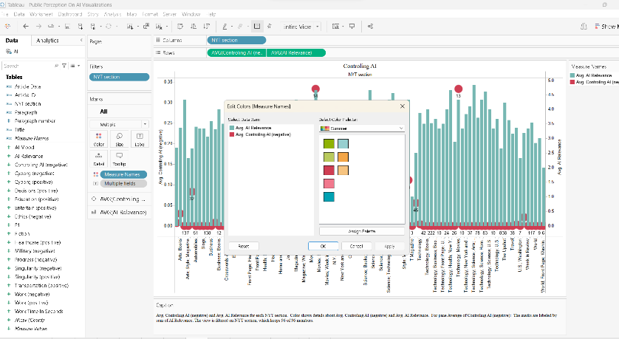

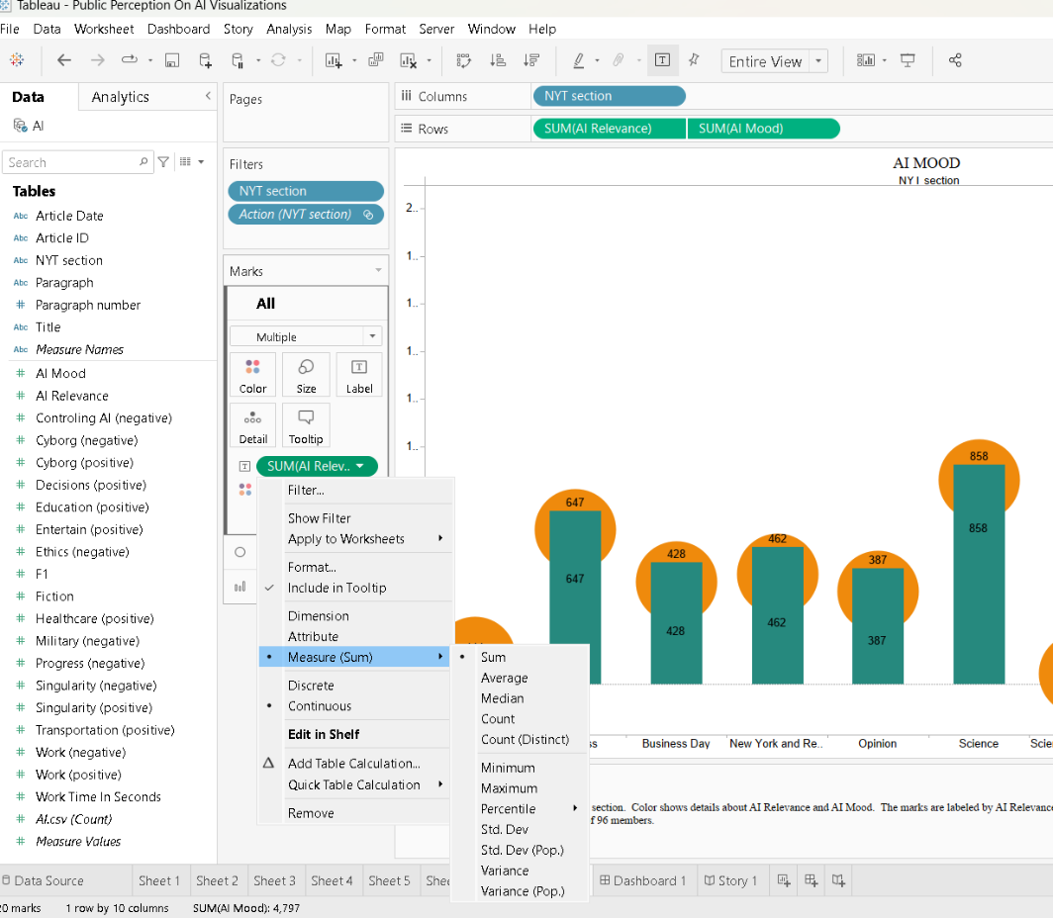

**Activity 3: No of Calculation Fields**

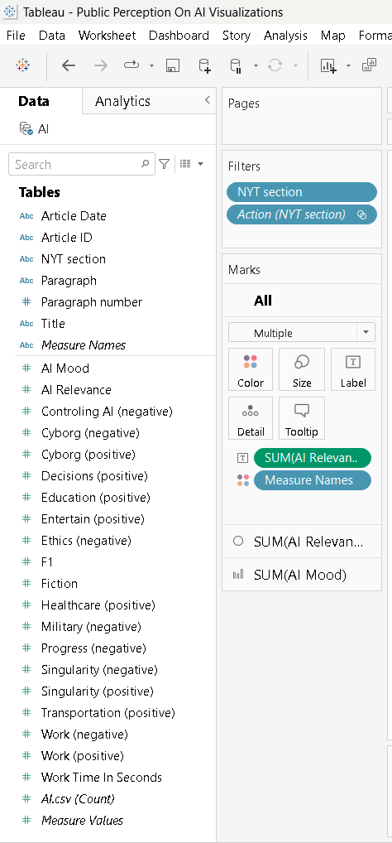

**Activity 4: No of Visualizations/ Graphs**

1)Official figure and Estimated value by year

2) value by year

3)Top 10 value-containing area

4)Flag Description based on year

5)Top 5 rice production countries with map

6)Countries with rice production

7)count of rice production across different countries from 1961 to 2021

8)Area and tonnes based on value

9)Total no.of tonnes

**Milestone 9: Web integration**

Publishing helps us to track and monitor key performance metrics, to communicate results and progress. help a publisher stay informed, make better decisions, and communicate their performance to others.

**Integrating dashboard/reports/stories to web**

Step 1: Go to **Tableau** and click on the server and publish your workbook .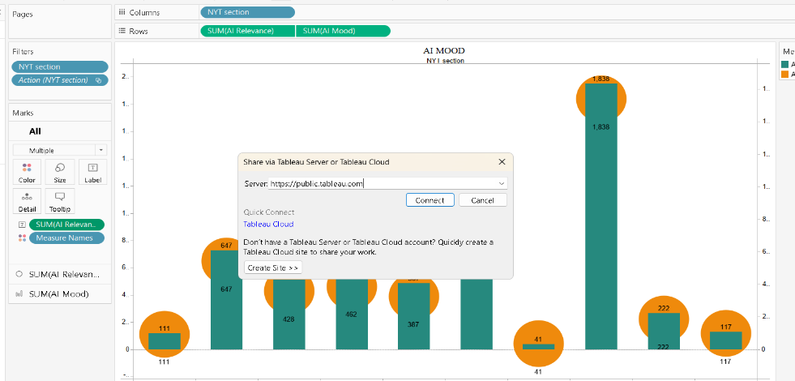

Step 2: Then enter your tableau public credentials. The sheet will be published to your tableau public account.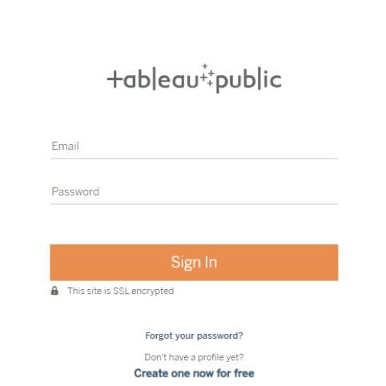

* Once you login into your tableau public using the credentials, the particular visualization will be published into the tableau public

**Note: While publishing the visualization to the public, the respective sheet will get published when you click on the share option.**

Step 3: Copy the link and paste it in your html page.

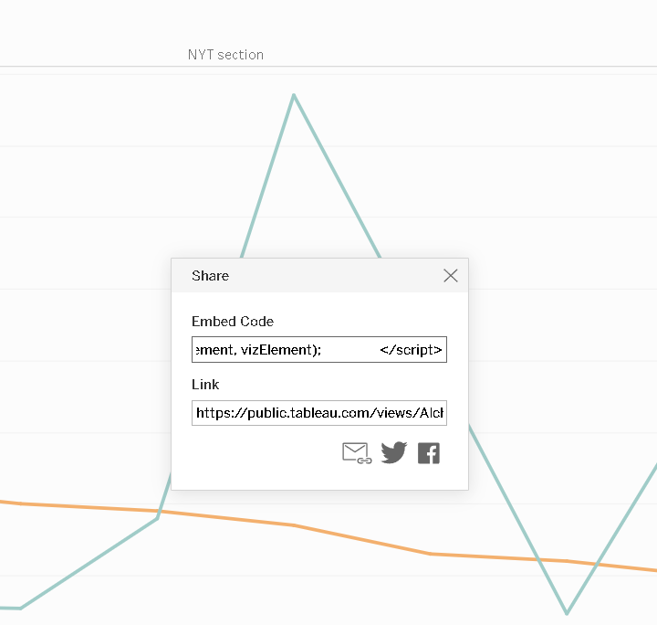

**Activity 1: Dashboard and Story embed with UI**

1. You have to Publish your sheet in your tableau public account.
2. Once you publish it, get the link as shown in the video below and paste it in your html code.
3. Then the sheets are displayed.

**Explanation video link:**[**https://dexterit-my.sharepoint.com/:v:/g/personal/sam_dexterit_onmicrosoft_com/ERjatd7ECuBDt684KIxI53cBYeDophDYzMAjcOLjbKdzVg?e=Ew1hRm**](https://dexterit-my.sharepoint.com/:v:/g/personal/sam_dexterit_onmicrosoft_com/ERjatd7ECuBDt684KIxI53cBYeDophDYzMAjcOLjbKdzVg?e=Ew1hRm%20)



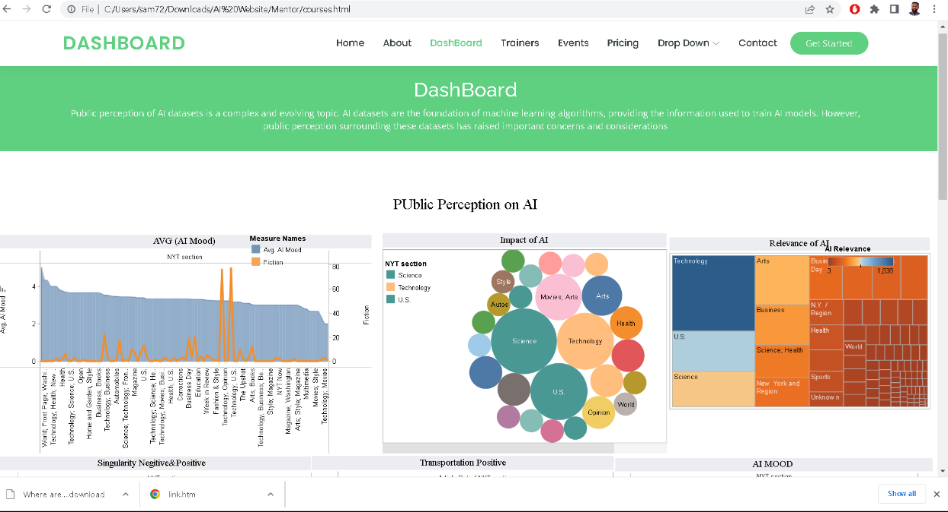

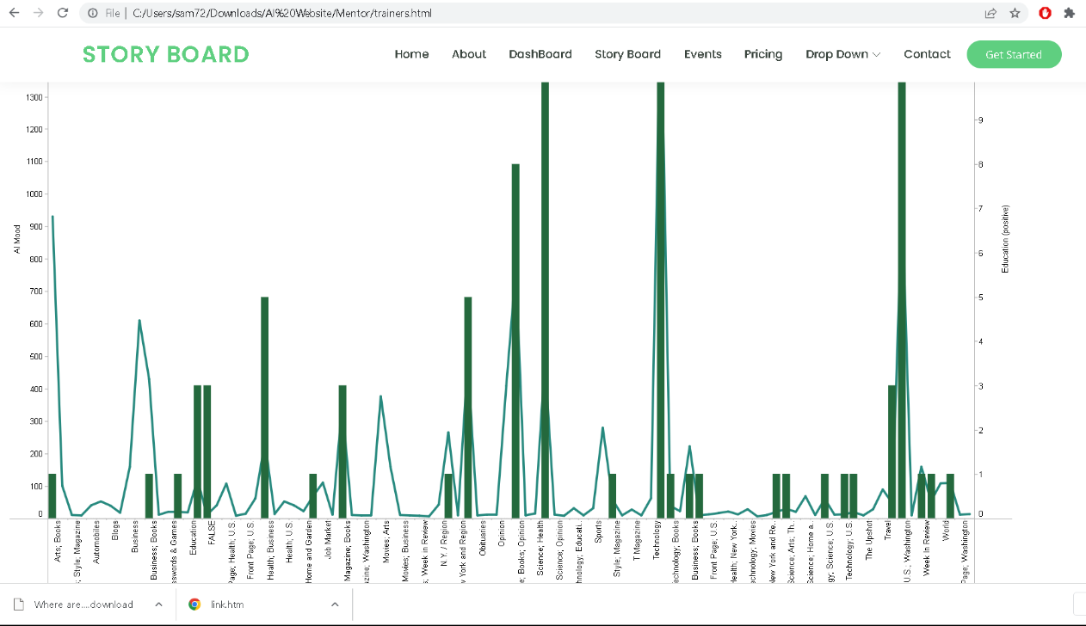

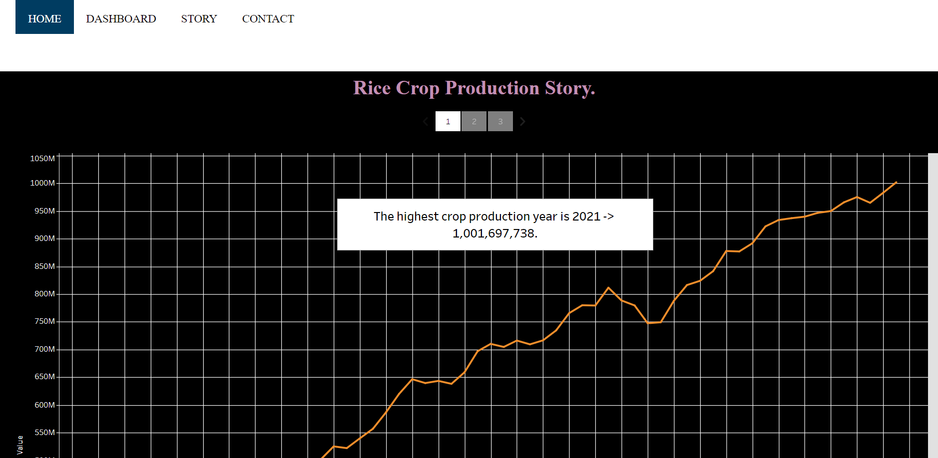

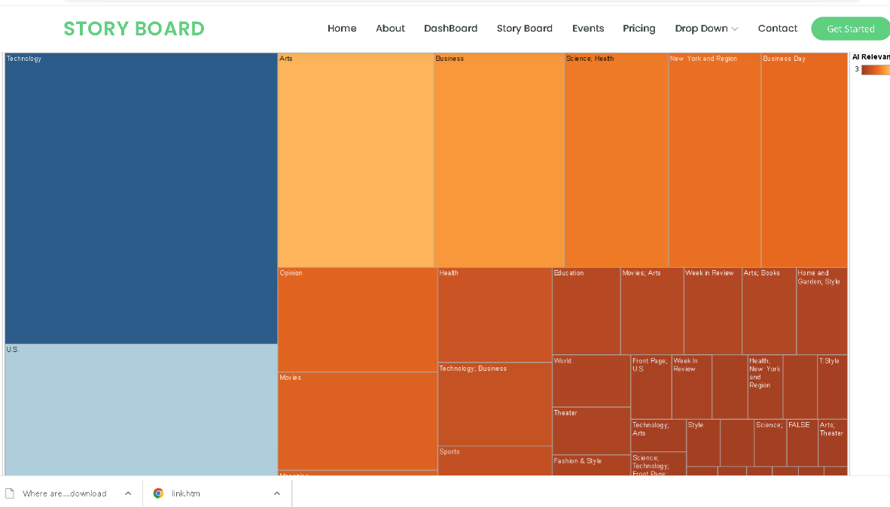

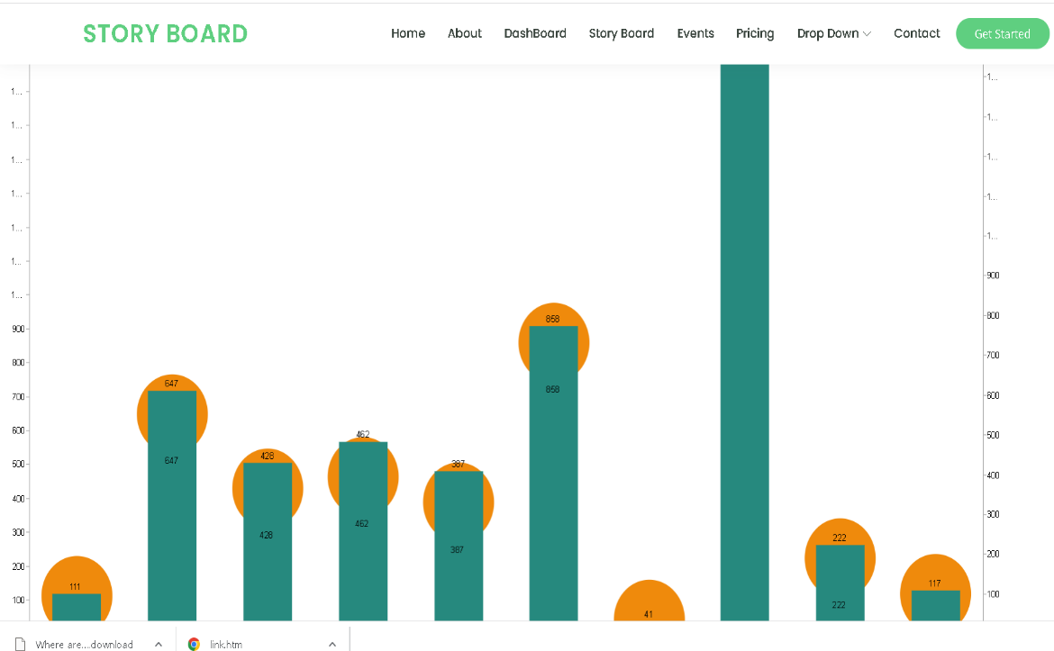

**Milestone 10: Project Demonstration & Documentation**

Below mentioned deliverables to be submitted along with other deliverables

**Activity 1:- Record explanation Video for project end to end solution**

**Activity 2:- Project Documentation-Step by step project development procedure**

Create document as per the template provided